46531 Harry Byrd Highway
Sterling, Virginia 20164
703-834-5800
admissionsteam@potomacfalls-rehab.com

Potomac Falls Health & Rehab Center
Transitional Care at Potomac Falls Health & Rehab

Stroke Specialty Program
Our professional Rehabilitation Team which includes Physicians and Nurse Practitioners, Nurses and Certified Nursing Assistants, Occupational Therapists, Speech Therapists, Physical Therapists, a Registered Dietitian, Case Manager and Social Worker. Our goal is to help you fully recover and return home when medically stable with the skills to perform daily living tasks.

We work with you as a team to stabilize your medical condition, improve your strength and functional status. You and your family will receive education on recognizing early signs and symptoms that could complicate your recovery.

Our services include, but are not limited to:
- Speech Therapy (ST) to provide exercise and training in articulation, swallowing and cognition.
- Physical Therapy (PT) to provide exercise and training to improve strength, endurance, flexibility, ambulation and balance.
- Occupational Therapy (OT) to focus on upper body including fine motor strength, coordination and promote independence in areas of daily living such as bathing, dressing, toileting and dining.
- Our ST and Registered Dietitian will assure nutrition and safety with swallowing if you need help regaining the ability to eat.
- Our Social Worker will work with you, your family, and your Rehabilitation Team to coordinate your Safe Transition Home.

Our goal is to help you “Get Well and Return Home” after hospitalization in a manner that is Safe and minimizes your risk for Re-Admission to the Hospital.

This is what our patients have to say about our Transitional Care Program:

J. Tyre –“I really enjoyed the therapists. I felt like I did great at Potomac Falls.”
Daughter of L. Ngamsanith – “The therapists are very good. Potomac Falls does a great job.”
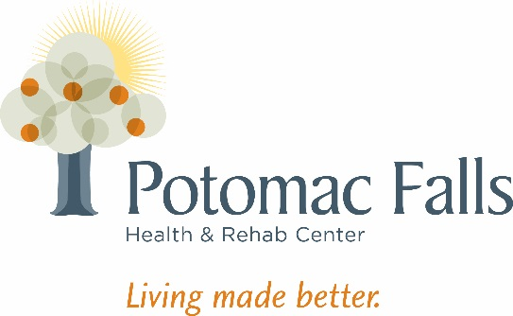
Wife of T. McQuillan- “All of the therapists (Occupational, Physical and Speech) have been kind and enthusiastic in helping me recover from my stroke. I really appreciate their skill patience and encouragement.”

