You may receive a variety of different services during your stay in the Transitional Care Unit, depending on your medical needs. Members of your care team include:
46531 Harry Byrd Highway
Sterling, VA 20164
703-834-5800
admissions@potomacfalls-rehab.com

Potomac Falls Health & Rehab
Meet the Transitional Care Team at Potomac Falls Health & Rehab

Admissions
The Admissions Team’s job is to help you make a smooth transition from an acute care hospital to our Transitional Care Unit by working with the hospital, your physician and your insurance company.
Physician
Throughout your stay, our physicians round on our patients and oversee your care. Both our attending physicians and Medical Director are experienced in working with the Transitional Care Team. Your physician at Potomac Falls will work with the Interdisciplinary Care Team to coordinate your rehabilitation needs.
Nurses
The Transitional Care Unit is staffed with registered nurses, licensed practical nurses and certified nursing assistants. The nursing staff works closely with your physicians and other members of your treatment team to develop a plan of care that meets your medical needs.
Physical Therapist
Physical Therapy (PT) is a rehabilitative service (which may be ordered by your physician as needed) which strives to:
- Improve movement
- Improve strength & endurance
- Decrease pain
- Heal a wound
- Help heal an injury
- Help you adapt to a disability and perform everyday activities such as getting in and out of bed, transferring from a bed to a wheelchair, walking, etc.
Occupational Therapist
Occupational Therapy (OT) consists of activities and exercises which use the mind and muscles together. It may be ordered for you to maximize your independence with daily activities such as:
- Bathing
- Dressing
- Feeding yourself
- Cooking
- Cleaning
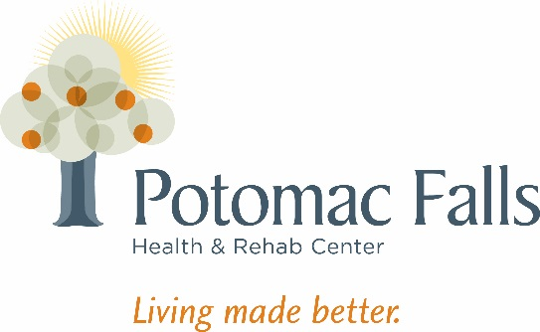
- Money management
- Medication Management
Occupational therapists also help you and your family decide if you need specialized equipment, such as grab bars or tub seats, to make your activities of daily living easier and safer when you return home.
Speech Pathologist_________________________________________________________________________
If your illness or injury has caused communication, memory or swallowing difficulties, your doctor may order therapy from a speech-language pathologist. The goals of speech pathology (ST) can include:
- To recover as much of your normal communication skills as possible
- To help you and your family become comfortable and skilled with new ways to communicate
- To help you overcome swallowing difficulties through strengthening exercises and safe swallowing techniques
- To help you improve memory and cognitive capabilities
Social Services
The Social Services Department interacts with the patients, their families and friends, as well all levels of staff within the center. This is essential to enhancing the opportunity for the patient’s positive experience while staying on the Transitional Care Unit. Other duties of the Social Services Department include, but are not limited to:
- Planning and coordinating a safe transition
- Counseling patients and their families
- Community Liaison for patients and their families
- Advocating and protecting resident/patient rights
- Ensuring the social and emotional needs of the patient are met
- Promoting the maximum level of independence of each patient
Nutritional Services
The Transitional Care Unit offers a varied menu with choices at every meal. Light refreshments are available on Transitional Care Unit. Our Registered Dietitian will assess your unique nutritional needs.
Activities Department
As part of your care, you will receive leisure support through programs planned by the Activities Department. The goal is to help you develop an independent leisure lifestyle which takes into account your interests, needs and abilities.

