Making the change from everyday life to receiving transitional care can be quite the transition. We want your experience to be as smooth as possible. This patient guide will help answer additional questions you may have about the details of being a patient at Potomac Falls Health & Rehab.
46531 Harry Byrd Highway
Sterling, VA 20164
703-834-5800
admissions@potomacfalls-rehab.com

Potomac Falls Health & Rehab
Transitional Care Patient Guide at Potomac Falls Health & Rehab

Reception and Information
A receptionist is available in our Lobby to provide directions and information from 8:00am – 8:00pm daily.
Visiting Hours
Recommended visiting hours are 10:00am – 8:00pm daily. Family and friends are invited to visit with you in community areas or in the privacy of your room. Children are always welcome to visit, but must be supervised at all times.
Because of our patients’ special needs, we request that visitors:
- Be careful not to interfere with therapy schedules
- Check with staff before bringing food into the center as some patients may be on a restricted diet
- Follow all rules and regulations as described by the staff
Patient Dining
Meals are served in the Dining Rooms on each hallway starting at the following times:
Breakfast: 8:00 am
Lunch: 12:00 noon
Dinner: 5:00 pm
Internet Access
The center is equipped with Wi-Fi, by joining the ‘CCR Guest’ network. No password is required.
Smoking
Potomac Falls Health & Rehab is a smoke and tobacco free campus. Smoking and the use of tobacco products are strictly prohibited on campus.
Valuables
Patients are responsible for their own belongings and valuables. We recommend you leave valuables at home.
Appointments_____________________________________________________________________________
Please notify us of all appointments to facilitate the best possible care and ensure maximized rehabilitation time.
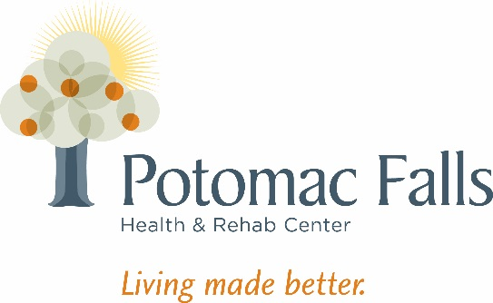
Customer Service
Any patient or family member has the right to express concerns and give us feedback on areas we can improve service in. Potomac Falls Health & Rehab provides an environment committed to Customer Satisfaction and Service Excellence.

