46531 Harry Byrd Highway
Sterling, Virginia 20164
703-834-5800
admissionsteam@potomacfalls-rehab.com

Potomac Falls Health & Rehab Center
Transitional Care at Potomac Falls Health & Rehab

Pain Management Program

The Pain Management program focuses on reducing and/or eliminating persistent pain which limits the patient in performing day to day functional activities effectively. Manual therapy techniques, range of motion, strengthening, aromatherapy, acupressure, massage and modalities such as electrical stimulation, and ultrasound are effective treatment approaches to resolve the pain symptoms. Therapists collaborate with the facility interdisciplinary team to gradually decrease pharmacological needs for pain management based on progress with the pain management program.

Our Rehabilitation department is equipped with a state of the art modality suite. This includes electrical stimulation, ultrasound, and diathermy. Modalities can be utilized to impact underlying deficits related to pain, falls, contractures, wound healing, continence improvement, and osteoarthritis. Use of modalities require a physician order along with the comprehensive plan of care.

Our Physical, Occupational, and Speech Therapists’ customized plan of care is developed leveraging the patient’s cognitive strengths and abilities. This program explores skills including daily problem solving and reasoning, memory, comprehension, sequencing, orientation, functional communication, social interaction, functional mobility and safe activities of daily living performance. Caregiver education, environmental modification and task simplification are key to the success of this program. Each patient’s Pain Management Program is customized based on physician recommendations and protocols. Our program includes the highest level of medical and nursing care, outside the hospital setting. In an atmosphere that is appreciated by both patients and their families, physicians and other highly-skilled professionals monitor each patient. Around the clock, Licenses Nurses and Certified Nursing Assistants provide care.

This care includes assistance with getting in and out of bed, feeding, bathing and dressing. In addition to Therapy and Nursing Team Members, our Transitional Care Team of Experts also includes a Licensed Dietitian, Licensed Social Worker, Payment Specialist, and Concierge who together provide compassionate, patient-centered care and are genuinely committed to patients returning to their lives as safely as possible.

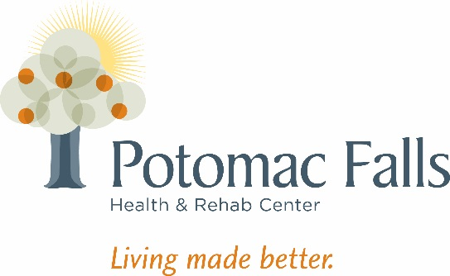
Our Goal is to help you “Get Well and Return Home” after hospitalization in a manner that is Safe and minimizes your risk for Re-Admission to the Hospital.

