46531 Harry Byrd Highway
Sterling, Virginia 20164
703-834-5800
admissionsteam@potomacfalls-rehab.com

Potomac Falls Health & Rehab Center
Transitional Care at Potomac Falls Health & Rehab

Orthopedic Recovery Program
The Orthopedic Recovery Program focuses on patients who have undergone a joint replacement, fracture, musculoskeletal injury or degenerative joint disease. In collaboration with orthopedic surgeons, primary care physicians and nurse practitioners, the rehabilitation team aims to improve balance, strength, range of motion, mobility, endurance and in return enhance activities of daily living to optimize independence and a safe discharge to home or a lower level of care. Physical and Occupational Therapists work very closely with physicians, and in many cases, follow protocols established by each physician. We partner with Accelerated Care Plus (ACP) which is the nation's leading provider of integrated clinical programs for sub-acute and long-term care rehabilitation providers. ACP's specialized treatment programs combine innovative medical technology with evidence-based clinical protocols and advanced therapist training.
Physical, Occupational, and Speech Therapists’ customize a plan of care using the patient’s cognitive strengths and abilities. This program explores skills including daily problem solving and reasoning, memory, comprehension, sequencing, orientation, functional communication, social interaction, functional mobility and safe activities of daily living. Caregiver education, environmental modification and task simplification are key program success.
Each patient’s Orthopedic Recovery Program is customized based on physician protocols and recommendations. Our Orthopedic Recovery Program includes the highest level of medical and nursing care, outside of a hospital setting. In an atmosphere that is appreciated by both patients and families, physicians and other highly-skilled professionals monitor each patient.

Care includes assistance with getting in and out of bed, bathing and dressing. In addition to Therapy and Nursing, our Transitional Care Team of Experts also includes a Registered Dietitian, Social Worker, and Insurance Specialists who provide compassionate, patient-centered care and are genuinely committed to patients returning home as safely as possible.

Our Goal is to help you “Get Well and Return Home” after hospitalization in a manner that is Safe and minimizes your risk for Re-Admissions to the Hospital.

This is what our patients have to say about our Transitional Care Program:
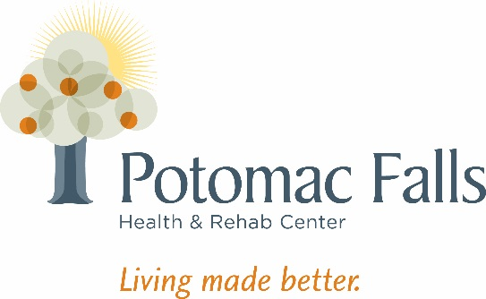
A. Didoha – “I strongly believe that it is the therapy staff and their positive encouragement and motivation that helped me accomplish my goals.”
P. Vigil – “I greatly appreciate everything everyone did for me, what a wonderful therapy staff”
C. Meyer – “This is a great place to be when you can’t be at home”

